Jews of Khazaria, brief history and other resources | eMail to a friend
http://www.palestineremembered.com/Acre/Maps/Story800.html
Posted on APRIL-3-2002
According to an article published at the World Zionist Organization's (WZO) website:
"REMARKABLY, the Khazars, a people of Turkic origin, converted to the Jewish religion sometime in the 9th century, beginning with the royal house and spreading gradually among the general populace. Judaism is now known to have been more widespread among the Khazar inhabitants of the Khazar kingdom than was previously thought. In 1999, Russian archaeologists announced that they had successfully reconstructed a Khazarian vessel from the Don River region, revealing 4 inscriptions of the word "Israel" in Hebrew lettering. It is now the accepted opinion among most scholars in the field that the conversion of the Khazars to Judaism was widespread, and not limited merely to the royal house and nobility. Ibn al-Faqih, in fact, wrote "All of the Khazars are Jews." Christian of Stavelot wrote in 864 that "all of them profess the Jewish faith in its entirety." Click here to view the full article and links to the original source.
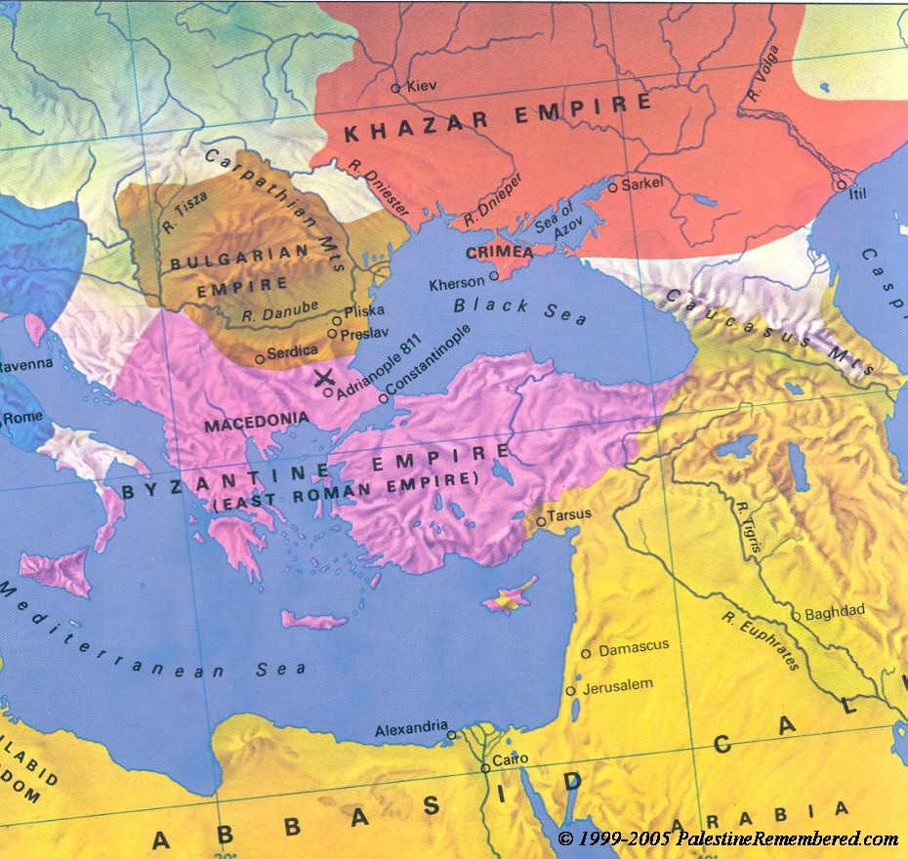
Source: Atlas of World History, p. 108

Related Links
- Wikipedia: Khazars.
- Khazaria, A hidden & forbidden Jewish history exposed
- The Thirteenth Tribe by Arthur Koestler
- In DNA, New Clues to Jewish Roots by the NY Times
- Zionist FAQ: The Land of Israel was promised to the descendents of Isaac by God
- NYTimes: , Geneticists Report Finding Central Asian Link to Ashkenazi Levite
- Khazri-Fiction: A Yahoo e-group that is for people interested in reading, writing, publishing, or distributing historical fiction novels and short stories about the Khazar Khaganate as well as other topics in Jewish, Slavic, and Turkic history
What is new?
-Nakba Oral History Video Podcast: Over 240 Oral History interviews (including 750 hours of recording) can be viewed now online.
-Satellite View & Google Earth: Over 3,000 placemarks identifying all destroyed towns, W. Bank & Gaza Strip Towns, & refugee camps.
-The ethnic cleansing of Palestine: George Galloway interviews Israeli Historian Ilan Pappe.
-Zionist FAQ now available in Hebrew שאלות שציונים שואלים, עכשיו בעברית
-Video: The Stephen Walt and John Mearsheimer report on the influence of the Israel Lobby on U.S. Foreign Policy
-The Nakba - an event that did not occur (although it had to occur) By Eitan Bronstein
-The Palestinian-Israeli conflict for beginners
-JNF: Financing Racism and Apartheid By Dr. Salman Abu Sitta
Back To Maps Home Page
Home | Mission Statement | Zionist FAQ | Maps | Refugees 101 | Zionism 101
Zionist Quotes | R.O.R. 101 | Pictures | Towns Listing | Ethnic Cleansing 101 | Search
Chronology | Site Tour | Profile | Guest Book | What's New? | FAQ | Links | Looting 101 | Contact
Oral History | DONATE
? 1999-2006 PalestineRemembered.com all rights reserved. All Pictures are copyright of their respective owners.

